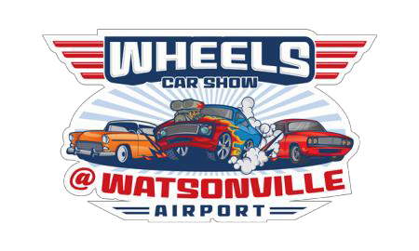
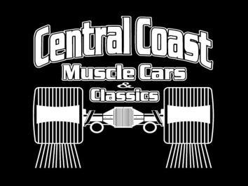
AIRPORT CAR SHOW
REGISTRATION FORM
10:00 am – 5:00 pm
APRIL 26, 2025
100 AVIATION WAY, WATSONVILLE

REGISTRATION INFORMATION

Name: ______________________
Address: _________________
City/State Zip: ________________
Phone Number: ________________
E-mail:________________________
MAIL YOUR REGISTRATION TO:
Watsonville Municipal Airport
100 Aviation Way, Watsonville, CA 95076
Questions? Call (831) 768-3575

WHAT’S GOING ON IN WATSONVILLE?
- Watsonville Airport is partnering with Central Coast Muscle Cars & Classics.
- A display of clean, cool collectible cars and trucks….any year, any model.
- Great local Music and Food.
- Opportunity to conduct a Dynamometer Pull (Not included in registration. Waiver required).
- $30.00 for two (2) “Dyno-Pulls”
- One free Dyno Pull raffled off by Central Coast Muscle Cars & Classics.

VEHICLE INFORMATION

Year: __________________________
Make: _________________________
Model: _________________________
Lic Plate #______________________
Club: __________________________
REGISTRATION FEES:
$40 – Vehicle Pre-Registration
(Due one week before show date.
Checks payable to “Watsonville Airport.”)
$50 – Vehicle Day of Event at the Gate
(Cash only, ATM available inside Terminal Building.)

WHAT ELSE DO I NEED TO KNOW?
- Bring your chairs and coolers (no alcoholic beverages).
- Umbrellas or shades attached to chairs are OK.
- Admission to the event is free for pedestrians, however vehicles must register.
- All pre-registered vehicles receive a “Goodie Bag”. Raffles during the event.
- Free event parking outside the display area.
- This is a “JUDGED EVENT,” and will be held “Rain or Shine”. Trophies and plaques awarded
WAIVER (BOX MUST BE CHECKED TO PARTICIPATE)
BY CHECKING THIS BOX REGISTRANT AND ENTRANTS HEREBY RELEASE AND DISCHARGE WATSONVILLE MUNICIPAL AIRPORT, CITY OF WATSONVILLE AND ALL MEMBERS OF CENTRAL COAST MUSCLE CARS & CLASSICS AND IT’S EVENT SPONSORS OF ANY AND ALL KNOWN AND UNKNOWN DAMAGES, INJURIES, LOSSES, JUDGMENTS AND/OR CLAIMS FROM ANY CAUSE WHATSOEVER THAT MAY BE SUFFERED BY ANY REGISTRANT/ENTRANT TO HIS PERSON OR PROPERTY. FURTHER, EACH REGISTRANT/ENTRANT EXPRESSLY AGREES TO INDEMNIFY ALL OF THE FORGOING ENTITIES, FIRMS, AND PERSONS FROM ANY AND ALL LIABILITY OCCASIONED OR RESULTING FROM THE CONDUCT OF REGISTRANTS/ENTRANTS OF ANY PARTICIPANT ASSISTING OR COOPERATING WITH THE REGISTRANT/ENTRANT UNDER THE DIRECTION OR CONTROL OF REGISTRANT/ENTRANT. WE RESERVE THE RIGHT TO REFUSE ADMITTANCE OR TO DISMISS ANYONE FOR UNACCEPTABLE CONDUCT AT OUR DISCRETION.

