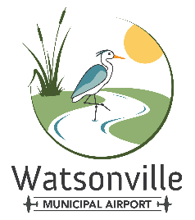
Watsonville Municipal Airport
100 AVIATION WAY  WATSONVILLE, CALIFORNIA 95076
MAIN: 831 768-3575  FAX: 831 763-4058

July 22, 2025

To: Airport Tenants, Leaseholders and Aviation Way businesses

Re: Municipal Airport Open House, August 30, 2025

The Municipal Airport will open its doors next month, August 30th from 4:30pm until 8:30pm, to the citizens of our local area. As you may know, an “Airport Open House” is an important part of a General Aviation airport’s community outreach effort. The purpose of this letter is to provide advance notice and invite you to join us.

In years past, Watsonville Airport Open House events have showcased the value, viability and vitality of our airport with a focus on the aviation assets that support the city, community and county. This year we will continue that tradition as CalFire, law enforcement and first responder aviation assets display their aircraft. No airport open house would be complete without a display of based aircraft. Watsonville Municipal tenants are encouraged to display personal, flying club, trainers and corporate aircraft.

This year’s Open House will include parachute flag jump, food trucks/vendors, live band, Kids Zone and conclude with a professional pyrotechnics display. In accordance with our “open house” format, walk-in admission is free. Passenger vehicles may park on the crosswind runway at no charge.

Given that aircraft operations continue, except during the flag jump and Fire-in-the-Sky display, there are a few logistical and access challenges to be considered. The reverse side of this letter outlines the details tenants and businesses should expect relative to field access and closure of Aviation Way.

If you have any questions, please don’t hesitate to contact the airport office.

We look forward to seeing you on August 30th as we celebrate the end of Summer, with “Fire-In-The-Sky!” at Your Airport Open House.

Best regards,
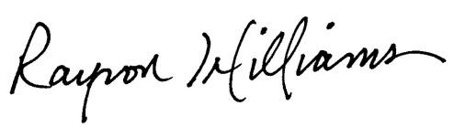
Rayvon Williams
Airport Director

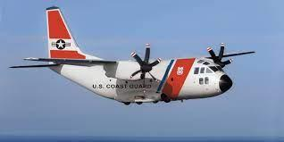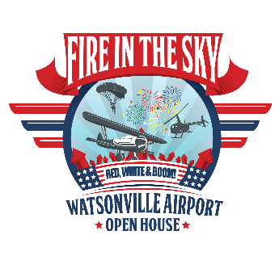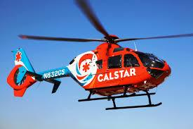

What? Watsonville Municipal Airport Open House “Fire In The Sky”
When? Saturday, August 30, 2025 from 4:30pm to 8:30pm
Where? 100 Aviation Way; Municipal Airport (see map below)
Why? Open airport to community. Showcase airport’s value to the public.
How? Public: Aviation Way limited vehicular traffic. Pedestrian access allowed. Follow signage for walk-in free admission. Vehicles follow signage; enter (Gate One) off Airport Blvd; Park on Crosswind runway (For Free!). Tenants: Access to Aviation Way is restricted to West Entry Only (Airport issued vehicle decal required), airport leaseholders, Aviation Way businesses and Event Sponsors (passes* required).

Check NOTAMs, airspace closed during Flag Jump and Pyrotechnics Display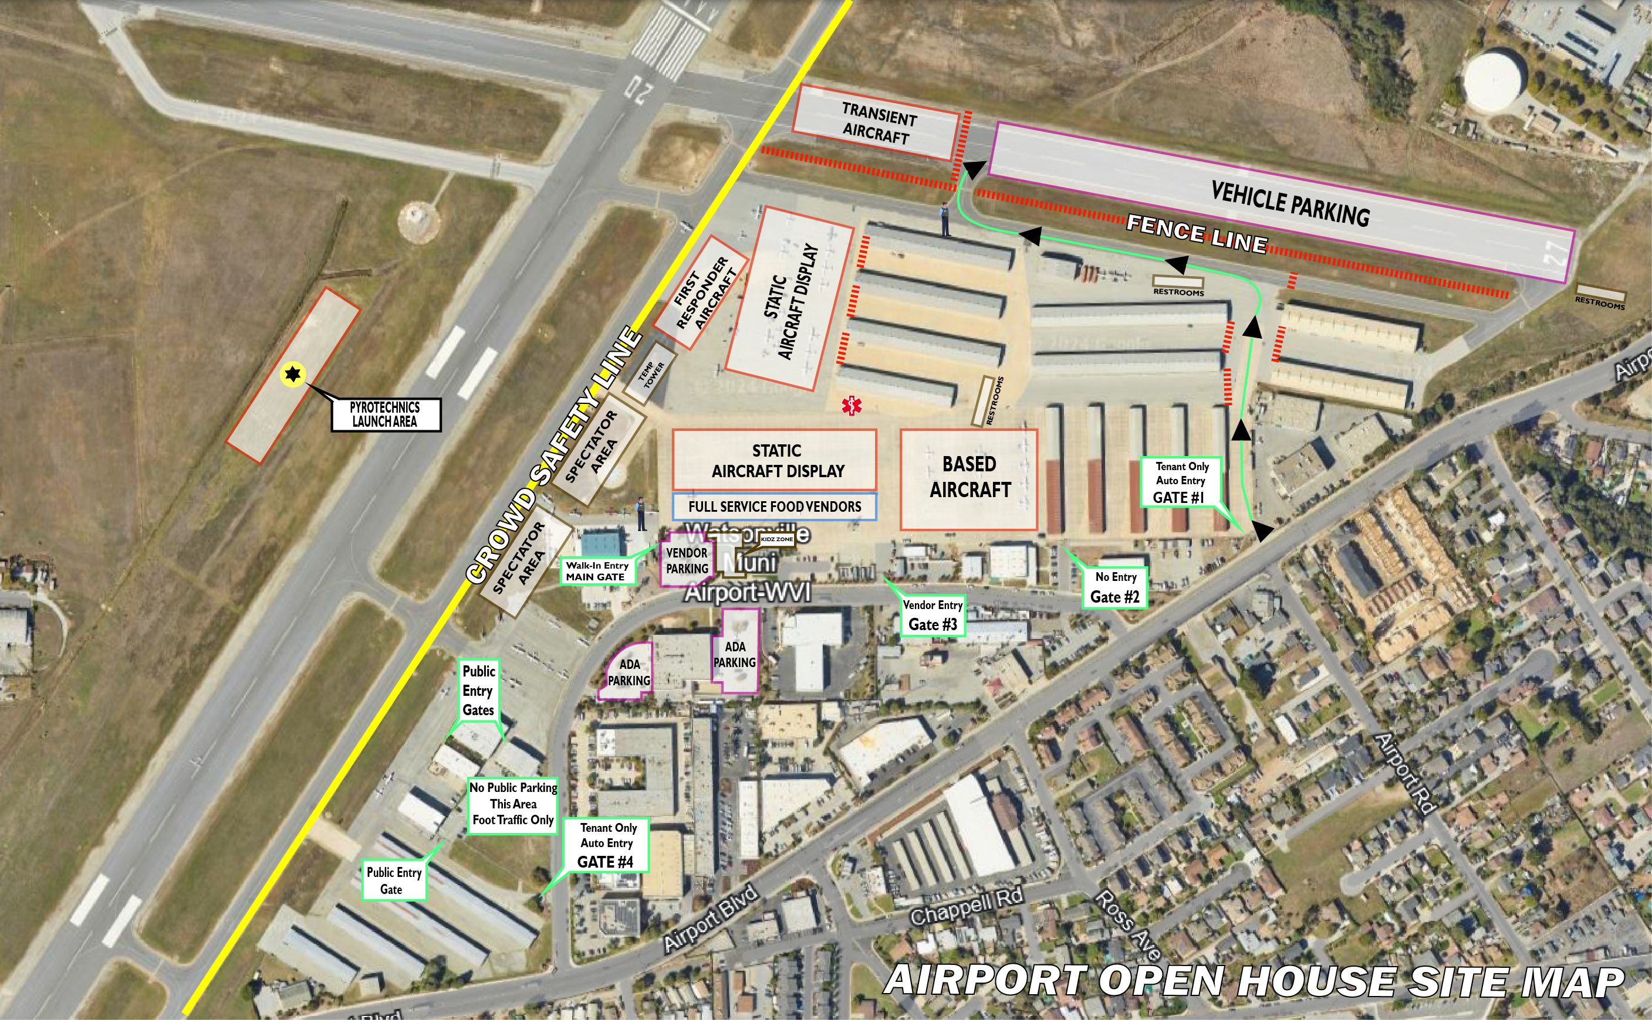
- Friday August 29, 2025 12:00pm: Runway 9/27 closure
- 4:30 – 8:30pm: Airport open to public
- Aircraft display, Food Trucks, vendors and Live Band.
- 2:00 – 3:30pm: First responder aerial arrivals, 6:00pm: National Anthem/Parachute demonstration
- At or about 8:00pm – Fire-In-The-Sky demonstration
- At CONCLUSION OF EVENT PORTIONS OF AIRPORT BLVD CLOSED TO TRAFFIC
- * Available beginning August 18th; Contact Airport Office (831) 768-3575
- ** Fuel Available via truck only 8:30am-5:00pm Saturday August 30, 2025

