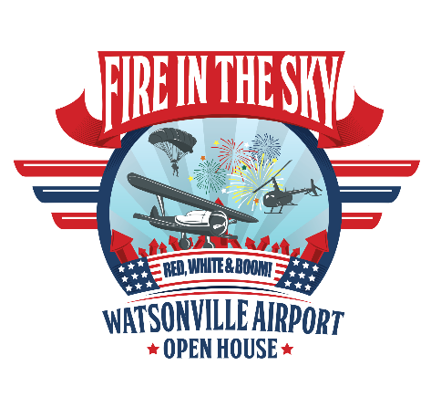

Watsonville Municipal Airport
100 AVIATION WAY  WATSONVILLE, CALIFORNIA 95076
MAIN: 831 768-3575  FAX: 831 763-4058

RE: Watsonville Airport Open House; support us as a Patron!

Watsonville Municipal Airport invites you to support the annual Airport's outreach to the Community, City and County during the upcoming Labor Day holiday period.

The Airport Open House is a community outreach effort inviting the public to visit their “Hometown Airport”. We open our doors for an up close and personal view of Military and first Responder aviation assets, antique aircraft, Food Trucks and Fireworks rounding out the event.

As a "Fire-In-The-Sky" Patron you are crucial to our success by providing financial, "in-kind" support at one of four Patron levels: Wingman, Flight Leader, Squadron Commander and Wing Air General. Each level provides an opportunity to contribute at levels commensurate with your commitment to support the operational and logistical cost of the free public event.

PATRON LEVEL DETAILS

Wingman Patrons contribute at least $1,000.
- Name Logo on event Posters and Website
- Banners displayed along public entrances

Flight Leader Patrons contribute at least $2,500.
- All Wingman offerings plus
- Designated as a "People Patron" (your donation supports Parking, Security, Sanitation) or sole Patron of Kidz Zone

Squadron Commander Patrons contribute at least $5,000
- All Flight Leader offerings plus
- Designated as a "Performing Patron" (Flag Jump, Live Music or Kidz Zone)

Wing Air Marshal contribute at least $7,500 (limited to only three Patrons)
- All Squadron Commander offerings plus
- Designated as a "Fire-in-the-Sky Patron"
- Patron Parking Terminal Lot
- Personal on-site tour with Airport Director…a behind the scenes look.

As a Patron at one of the above levels your TAX DEDUCTIBLE CONTRIBUTION will assist the Municipal Airport to once again provide our community a spectacular start to their Independence Day celebration for which Watsonville Airport is becoming well known.

Once again our Fire-In-The-Sky fun, family and free event is professionally created and will be seen by over 7,500 members of the community, city and county. We are hopeful you will join fellow Patrons and Businesses just like yours.

Please take a moment to consider a Patron level that best meets your individual and/or business needs.
Remember…this year it’s RED, WHITE and ZOOM!

Sincerely,

Rayvon Williams
Director, Municipal Airport

PATRON COMMITMENT FORM
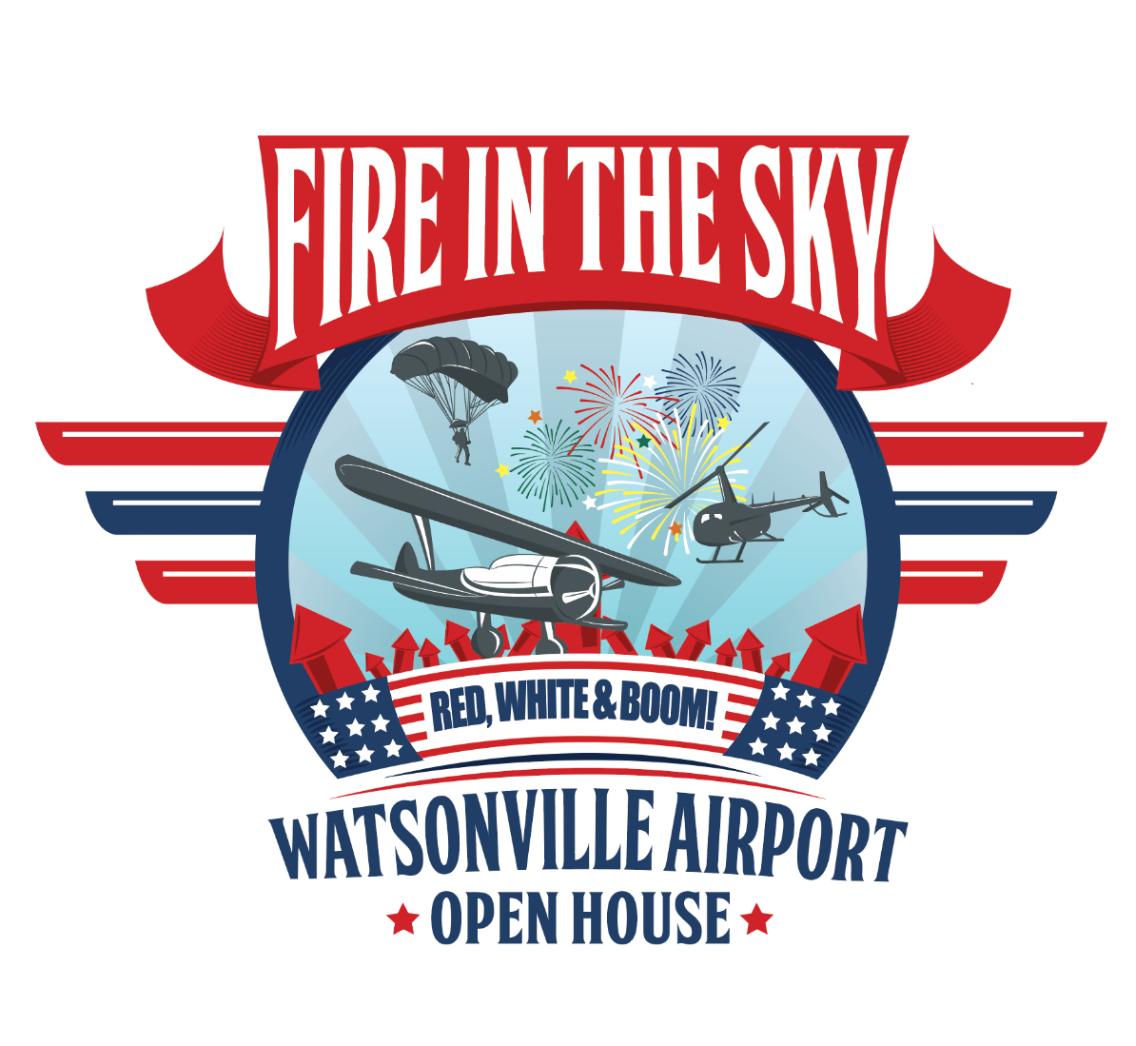

Name(s) to appear in respective materials: ___________________________________________

Amount of Tax deductible donation*: ________________________________________________

Mailing address: ________________________________________________________________

______________________________________________________________________________

Airport Open House element designations: ___________________________________________

Please make all checks payable to:

City of Watsonville
Municipal Airport
100 Aviation Way
Watsonville, California 95076

*Note Acct Number #5895 on “Memo line”

